Put Waste in its Place for Clean Water
As a business owner, you are responsible for all pollutants that leave your property. You play a big role in keeping our waterways clean and healthy! Do your part by keeping your property clean and properly storing your trash until pick-up.
DO | DON’T
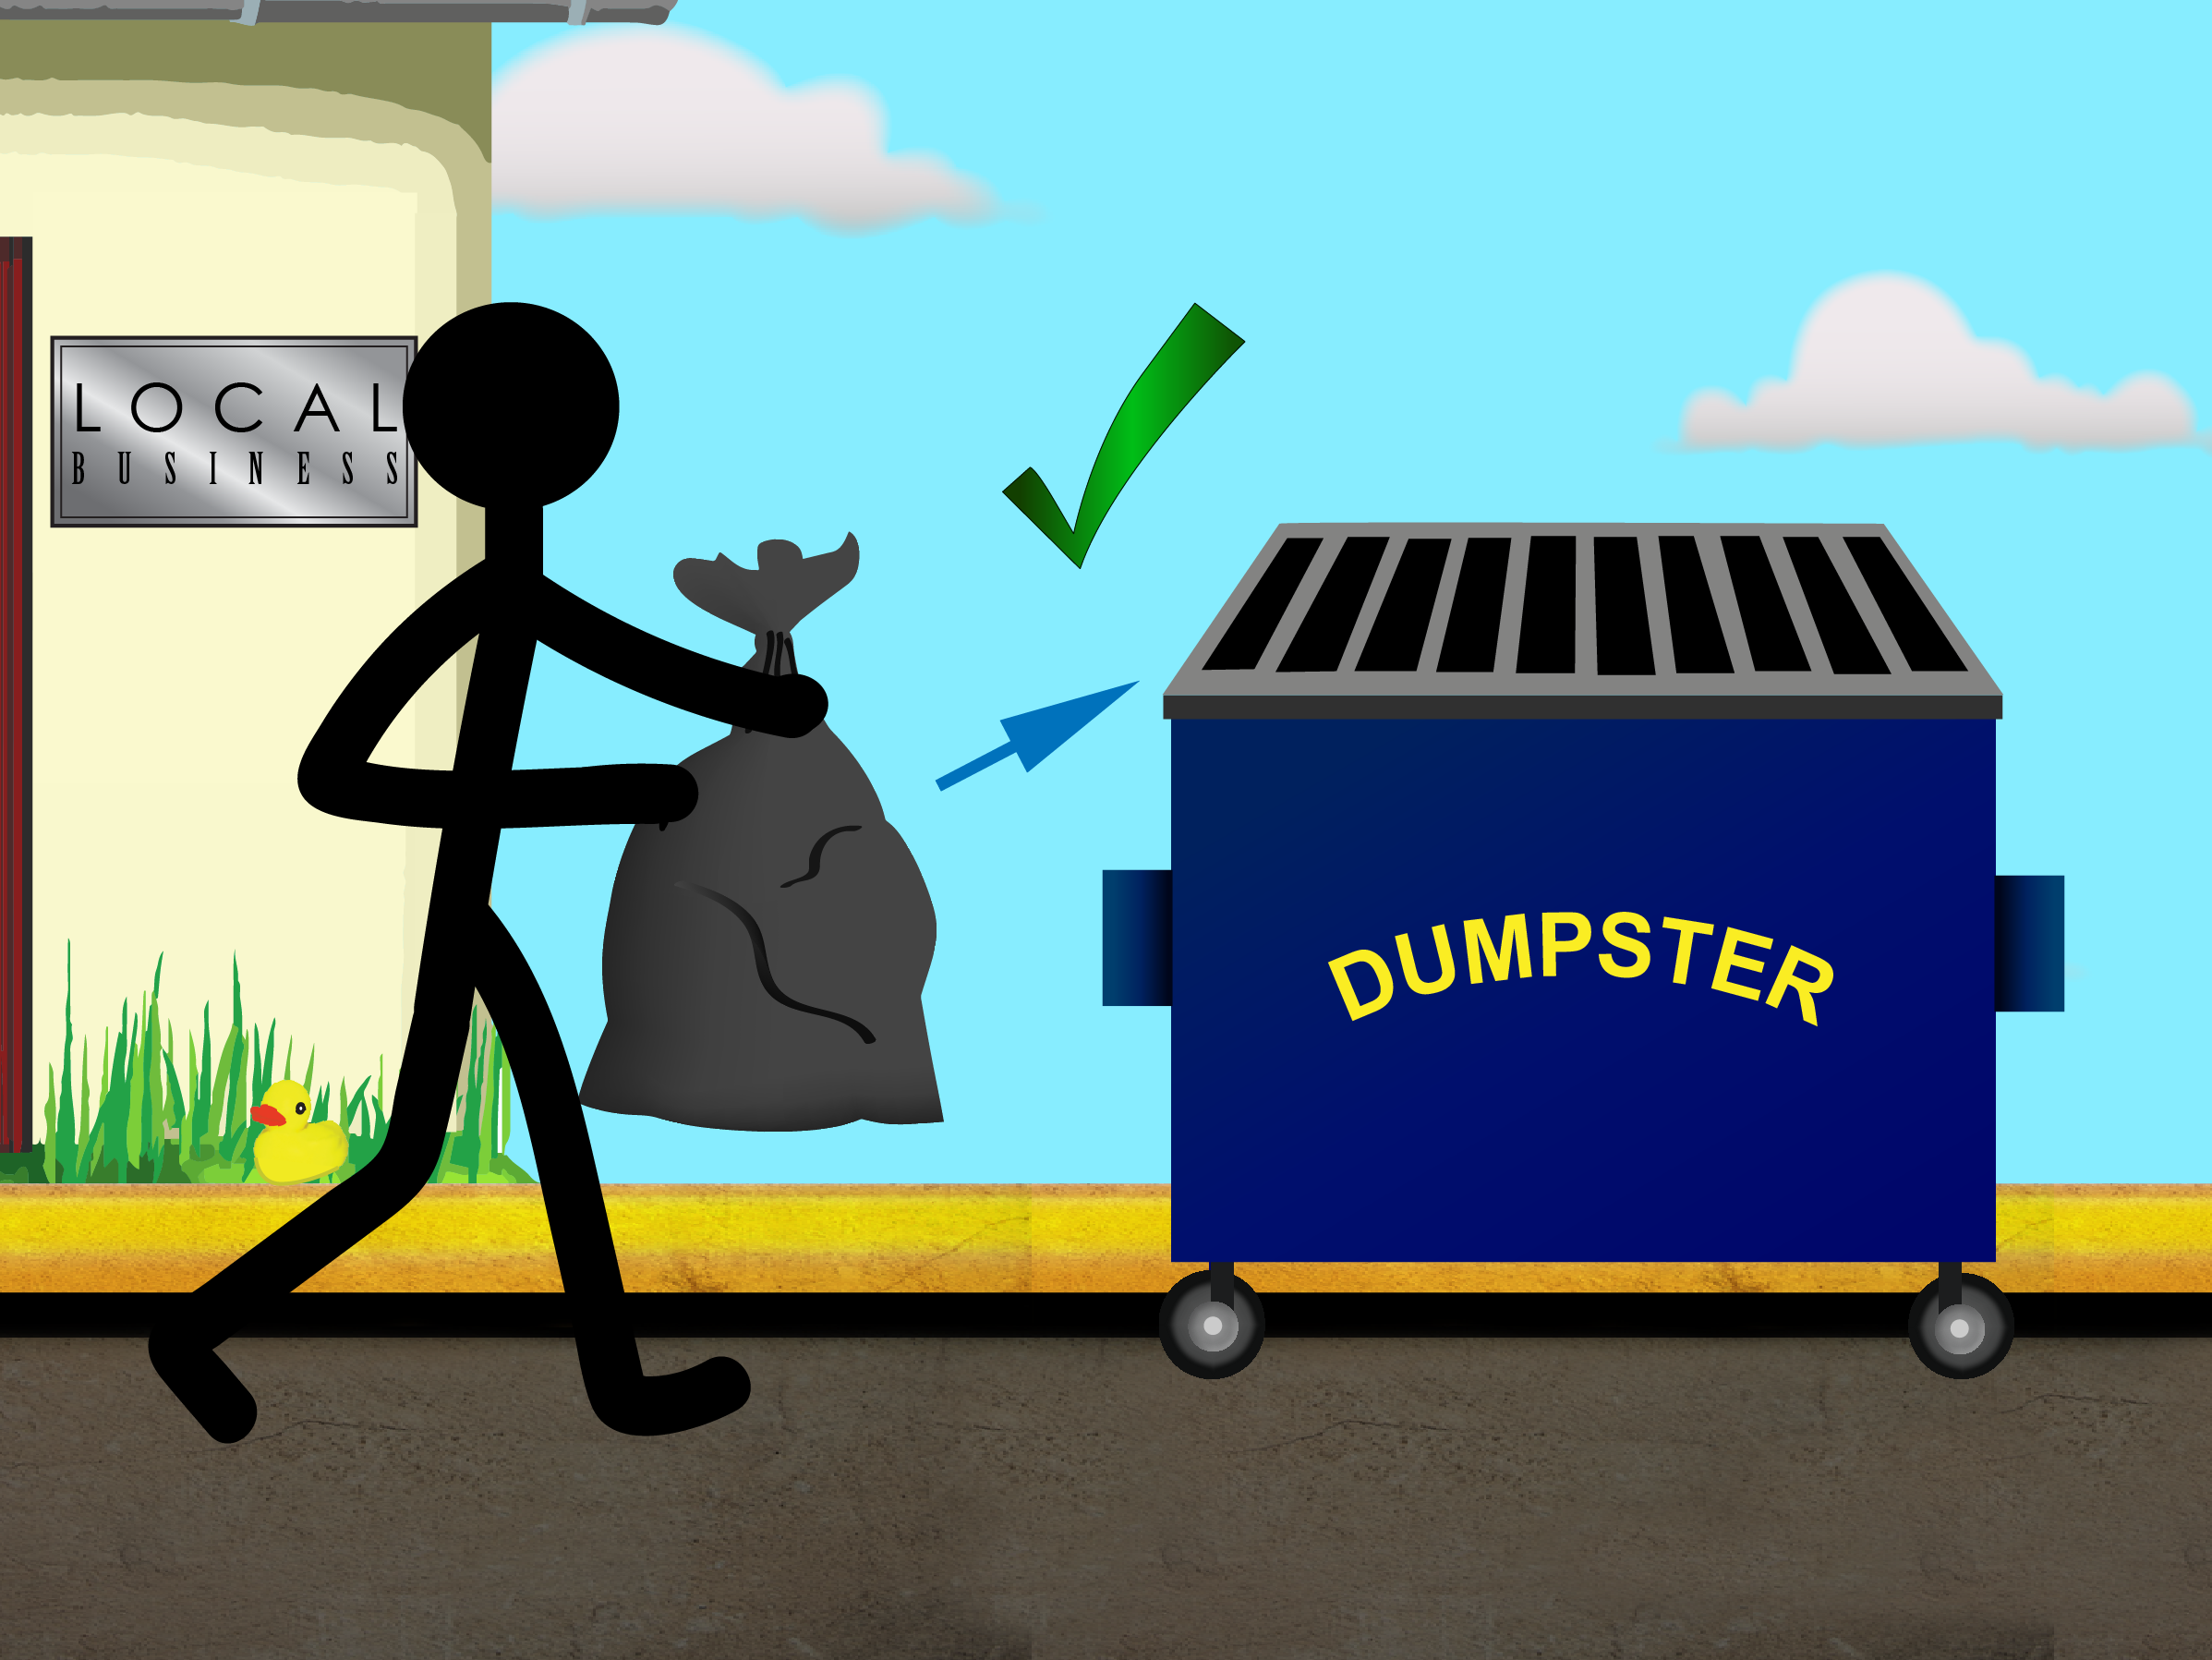 | 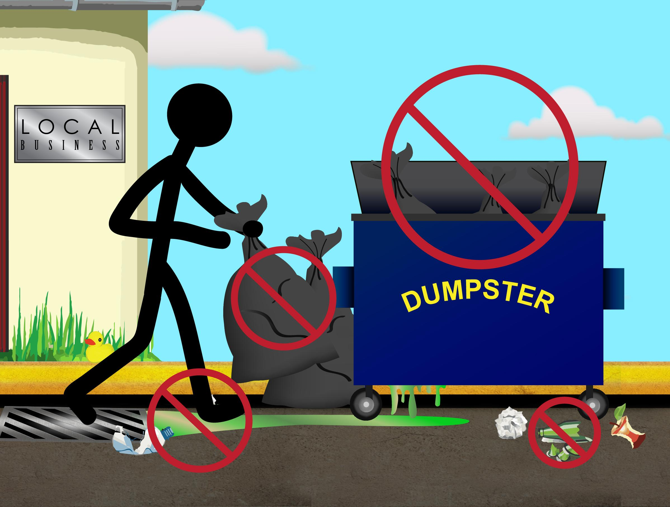

- Inspect your dumpster daily.
- Make sure the lid is kept closed and locked.
- Check for leaks and replace, if needed.
- Schedule regular trash pick-ups to prevent the dumpster from becoming too full.
- Don’t place leaking containers in the dumpster when emptying trash.
- Though it’s sure to get smelly, never hose down the inside of your dumpster.

Why is this necessary?
Rain that falls into and around your dumpsters can pick up trash and dirt as it drains away. Much of this water, or stormwater, ends up in our lakes, rivers, and streams. It’s the fastest growing type of water pollution in Massachusetts. Stormwater pollution is bad business for our state’s waterways. It harms fish and wildlife, makes our water unsafe to drink, and can spoil outdoor activities. Business owners can do their part to keep Massachusetts’ waterways clean. Find more tips like these at www.ThinkBlueMassachusetts.org

