Gas, Oil, and Grease...Oh My! Do Your Part to Stop Spills and Leaks at the Source

DO | DON’T
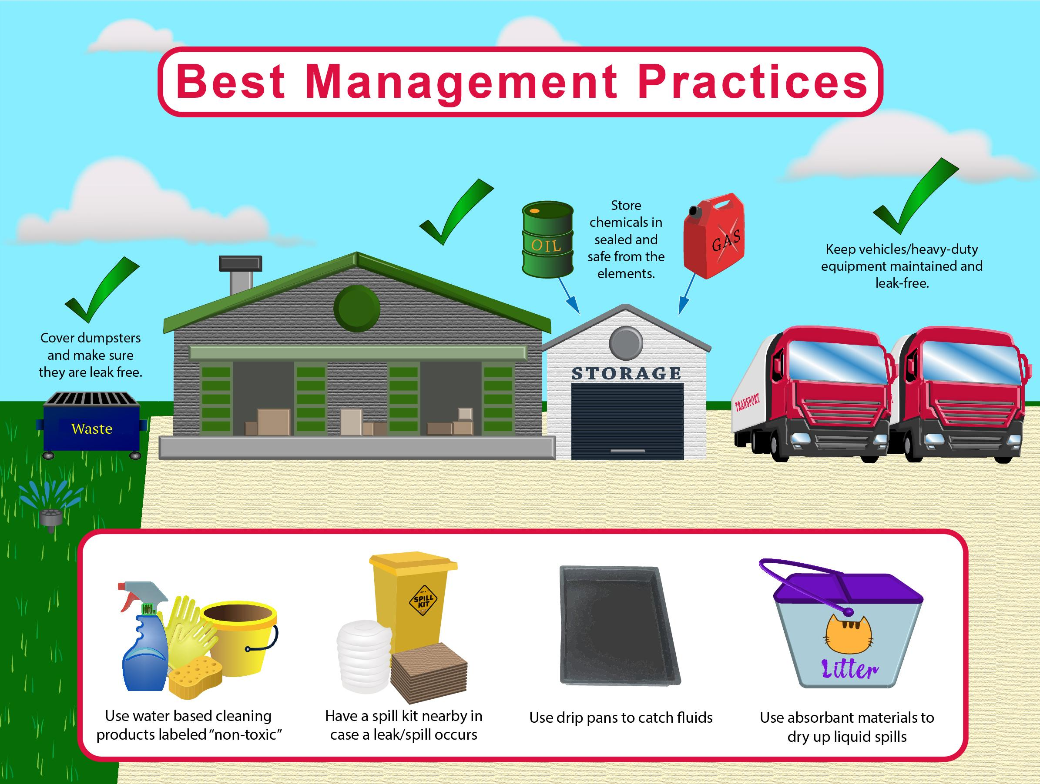 | 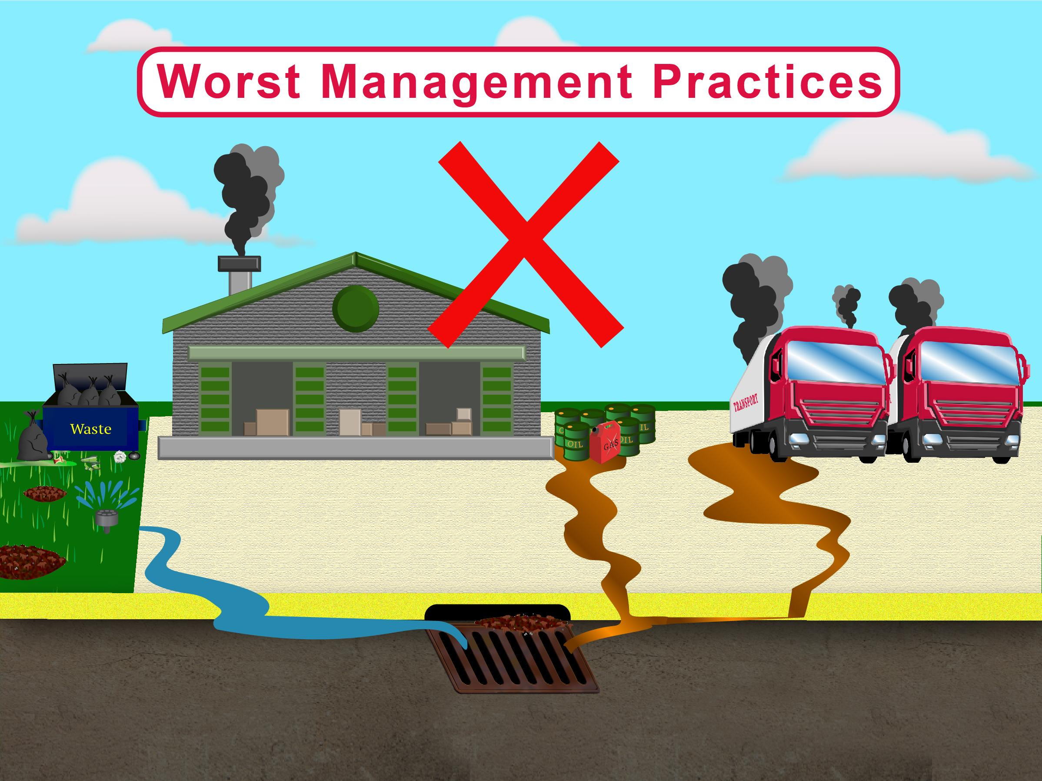

What can you do?
- Inspect your vehicles and equipment for leaks regularly.
- Use drip pans to catch fluids and keep a cleanup kit nearby in case a spill occurs.
- Cleanup spills immediately.

Why is this necessary?
- Gasoline, oil, and grease from vehicles and equipment can wash into storm drains.
- Water that enters storm drains eventually ends up in our lakes, rivers, and streams.
- Once pollutants reach these waterways, they can harm fish and other wildlife.
- This pollution can even make our water unsafe to drink.

Your industrial facility may be covered by a Multi-Sector General Permit. Under this type of permit, your facility needs to have a Stormwater Pollution Prevention Plan. This plan shows the steps you will take to reduce stormwater pollution. To learn more, check with the Conservation Commission.
Learn more at: www.ThinkBlueMassachusetts.org

