Stop Erosion in its Tracks to Keep Our Waters Clean

DO | DON’T
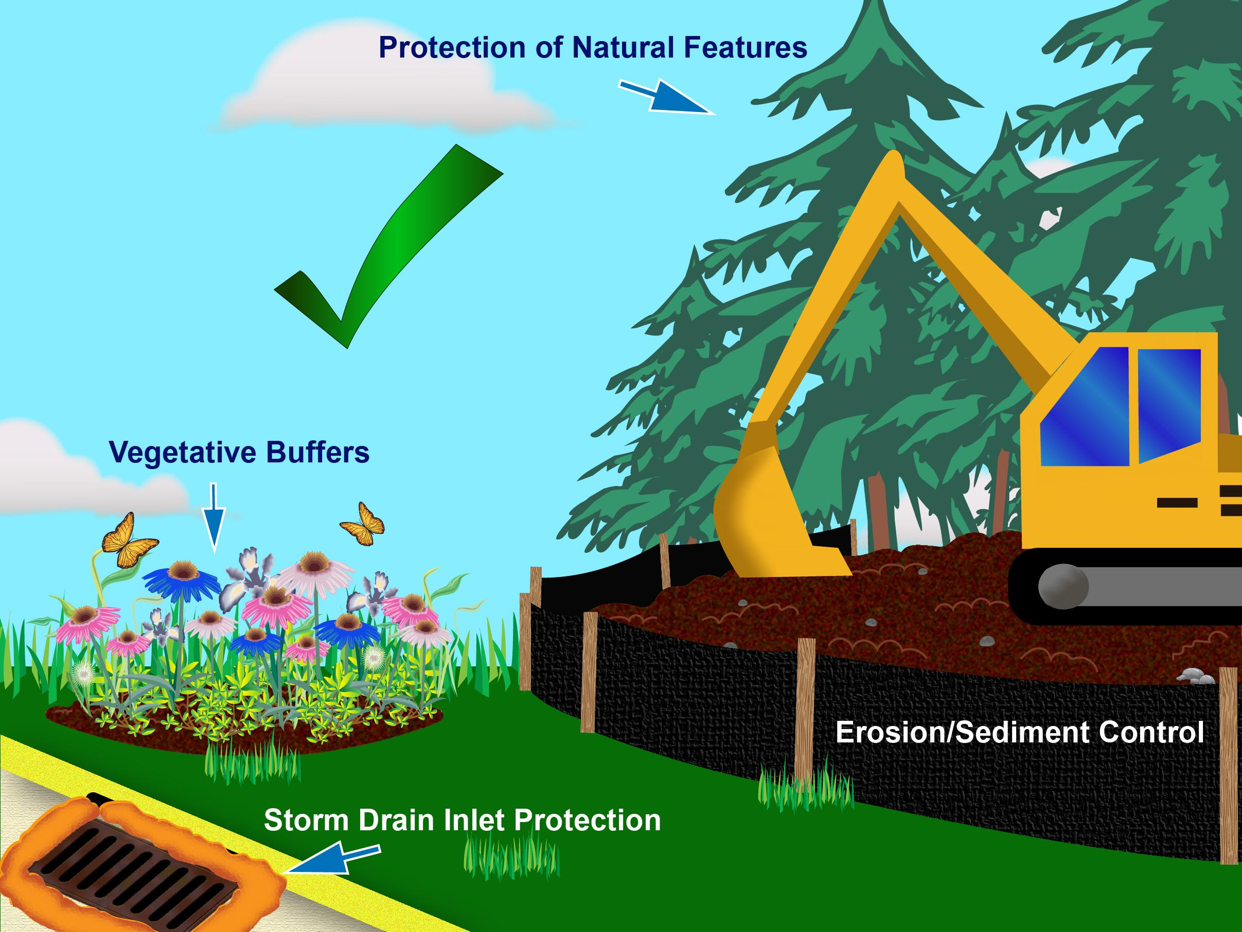 | 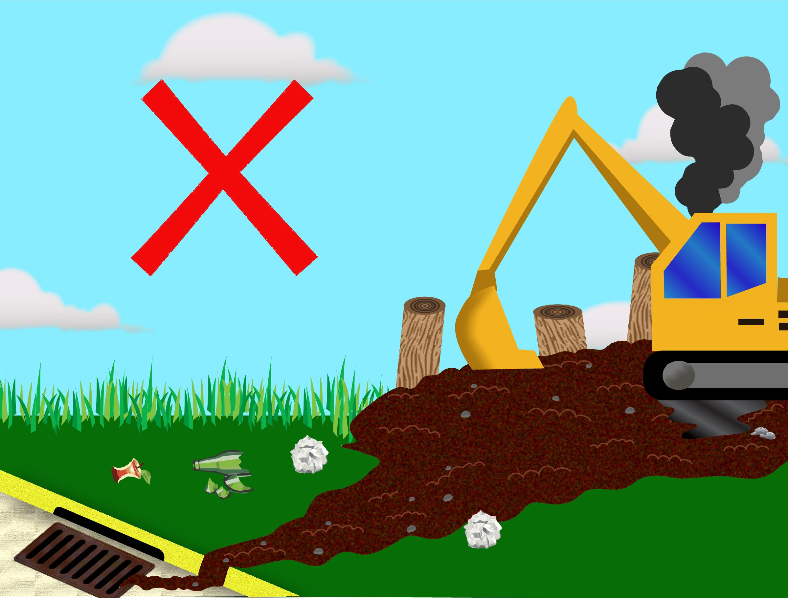

What can you do?
- Find out if you need a Construction General Permit.
- Contact the Conservation Commission before you disturb the soil.
- Pick a combination of erosion and sediment controls that work for your site.
- This includes practices that protect natural landscape features, like streams and wetlands, and stabilize soil.
- You will also need to use practices to protect and maintain silt fences, storm drain inlets, and construction entrances.

Why is this necessary?
- Water that falls on your construction site either soaks into the ground or runs off into storm drains.
- Water and pollution that goes into storm drains eventually ends up in lakes, rivers, and streams.
- Once these pollutants reach waterways, they can harm fish and other wildlife. They can even make our water unsafe to drink.
- Most importantly, allowing polluted runoff to leave your site and enter a storm drain or waterway is against the law.

Learn more at: www.ThinkBlueMassachusetts.org

